LCM,HCF problems:
Link:sevenmentor
Q.15 Quora
Q.5 is different
Q.6 I don’t have solution
Q.15,19,5 are strangest
Ex.1 The HCF of two numbers is 13 and the other two factors of their LCM are 11 and 14. The smaller of two is:
- a) 113 b) 143 c) 242 d) cannot be determined
Solution:
i)Hcf of two number is 13 means,
for number x,y
x%13=0 and y%13=0
Or you can say
After prime factorization of x
–> the components of x/13 cancel out.
Same with y.
ii) Other two factors of LCM are 11 and 14
Lcm is like
c times Original no Or d times original number
the say other two factors are 11 and 14
The smaller of two are
13*11
13 is bcoz
only cuz hcf is like what is common in both.
Smaller of two that is definitely 11.

Ex.2 Six bells commence tolling together at the intervals of 3, 6, 9, 12, 15 and 18 respectively. In 30 minutes, do they toll together?
- a) 10 b) 15 c) 11 d) 18
Solution:
We know LCM can be used to see when two or more thing overlapped
For e.g
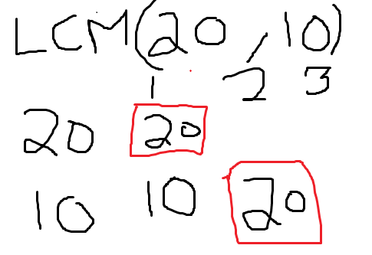

i)
LCM(3,6,9,12,15,18)=180
180 sec is 3 minutes.
So in 30 minutes it overlapped 30/3=10 times.
ii) Since it said it commence tolling together
so it is 10+1 =11 times.

Ex.3 Find the greatest number of 4-digit which leaves remainder of 3 when divided by 8, 16, 24, 48.
- a) 9987 b) 9984 c) 9848 d) 9948
Solution:
So We first find a number
when divided by 8,16,24,48 it will give 0.
x%8=0 , x%16=0, x%24=0, x%48=0
it basically includes all the numbers we have after prime factorization.
Aka
LCM(8,16,24,48)=48
So we need it to be 4 digit number close to
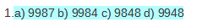
So we get 48*208=9984
Since we need a remainder 3.
I.e 9984+3=9987
Ans: 9987

Ex.4 Product of two numbers is 16464. If their LCM is 1176, find their HCF.
- a) 18 b) 25 c) 20 d) 14
Solution:
LCM includes all the construct of the the number.
HCF includes the construct of the number that is common in both.
LCM*HCF is Like multiplying x*y
LCM is like a set of A U B
HCF is like (A intersection B)
so LCM*HCF
is like getting all the Components back unique and common.
LCM*HCF=16464
1176*HCF=16464
HCF=14

Ex.7 Which of the following cannot be the HCF of the numbers whose LCM is 160?
- a) 32 b) 48 c) 80 d) 20
Solution:
HCF is a number which is common in both or all.
It divides them both or all into equal parts.
16/8=0
So we brute
160/48 result into irrational number.
Ex.9 The product of LCM and HCF of two numbers is a square of 25. If one of the numbers is 125, then what is the other number?
- a) 15 b) 5 c) 425 d) None of these
Solution:
LCM*HCF=625
same as saying
x*y=625
if x is 125
125*y=625
y=5
Ex.10 Find the greatest 3-digit number that is exactly divisible by 15, 25, 20 and 30.
- a) 930 b) 990 c) 900 d) 887
Solution:
x%15=0 , x%25=0, x%20=0, x%30=0
LCM(15,25,20,30)=300
So we multiply 300*3
900 which is the ans

Ex.11 What will be the least number which when doubled will be exactly divisible by 14, 21, 24 & 35?
- a) 420 b) 840 c) 1050 d) 630
Solution:
x%14=0, x%21=0, x%24=0,x%35=0
it should include all the components
So,
LCM(14,21,24,35)=840
Ans is 420 cuz which when doubled.
Ex.12 The least number that should be added to 2578 so that the sum is exactly divisible by 5, 6, 4 and 10 is:
- a) 11 b) 2 c) 35 d) 19
Solution:
A number divisible by 5,6,4,10
x%5=0, x%6=0, x%4=0, x%10=0
So,
LCM(5,6,4,10)=60
Since 2578 is 4 digit to get to this number
Nearest multiple of 60 is
60*43=2580
so 2578+2
Ans is 2

Ex.13 Three friends J, K and L jog around a circular stadium and complete one round in 12, 18 and 20 seconds respectively. In how many minutes will they all meet again at the starting point?
a) 5 b) 12 c) 3 d) 8
Solution:
LCM(12,18,20)=180 sec
180/3=3 minutes
Ex.14 How many pairs of numbers are there such that their HCF and LCM are 12 and 924 respectively?
- a) 1 b) 2 c) 3 d) 4
Solution:
HCF*LCM=x*y
HCF*LCM=12x*12y
12*LCM=12x*12y
924=x*12y
924/12=77
77=x*y
which is (11,7) or (7,11) I.e 2 pairs

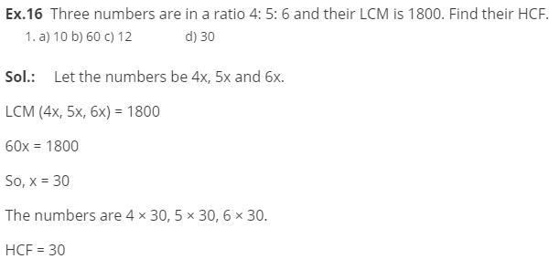
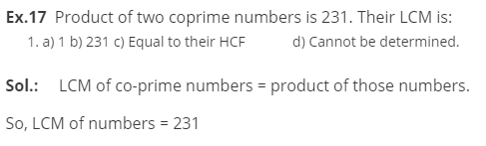

A Co-prime number is a set of numbers or integers which have only 1 as their common factor i.e. their highest common factor (HCF) will be 1
Ex.18 Three cloths of 7m, 7.5 m and 9.5 m, respectively have to be cut into same length pieces of maximum size. What will be the number of pieces?
- a) 24 b) 48 c) 120 d) 96
Solution:
Same length of maximum size
we need to find gcd or hcf or gcf
highest common factor
hcf(7,7.5,9.5)=0.5
so no of pieces is gonna be
7/0.5+7.5/0.5+9.5/0.5
= 48
Ex.20 What is the least multiple of 8 which leaves a remainder of 4 when divided by 6, 9, 15 and 18?
a) 184 b) 150 c) 183 d) 178
Solution:
LCM(6,9,15,18)=90
Least multiple of 8 means it should be divisible by 8.
Since 94 is not divisible by 8
Ans is 184 since it is divisible by 8 and leaves a remainder 4 when divided by 6,9,15,18.

Ex.15 Let A be the greatest number that divides 3900, 4650 and 6325 leaving same remainder in each case. What is the sum of digits of A?
- a) 7 b) 19 c) 22 d) 34
Solution:
